4. Hard and Soft SVM

I would like to continue with the above example.

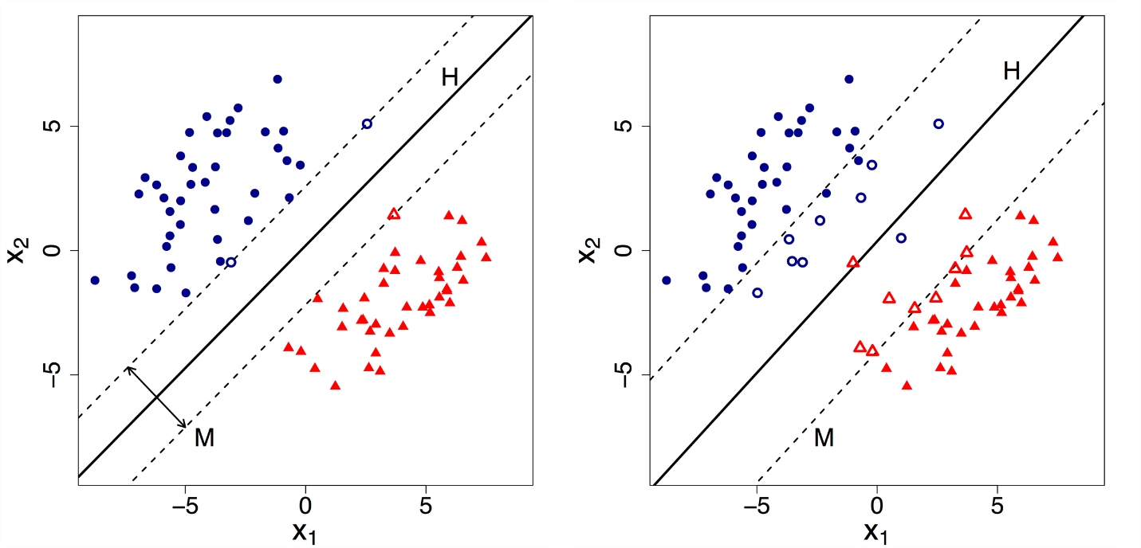

We can now clearly state that HP1 is a Hard SVM (left side) while HP2 is a Soft SVM(right side).

By default, Support Vector Machine implements Hard margin SVM. It works well only if our data is linearly separable.

Hard margin SVM does not allow any misclassification to happen.

In case our data is non-separable/ nonlinear then the Hard margin SVM will not return any hyperplane as it will not be able to separate the data. Hence this is where Soft Margin SVM comes to the rescue.

Soft margin SVM allows some misclassification to happen by relaxing the hard constraints of Support Vector Machine.

Soft margin SVM is implemented with the help of the Regularization parameter (C).

Regularization parameter (C): It tells us how much misclassification we want to avoid.

– Hard margin SVM generally has large values of C.

– Soft margin SVM generally has small values of C.

5. Relation between Regularization parameter (C) and SVM

Now that we know what the Regularization parameter (C) does. We need to understand its relationship with Support Vector Machine.

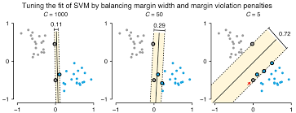

– As the value of C increases the margin decreases thus Hard SVM.

– If the values of C are very small the margin increases thus Soft SVM.

– Large value of C can cause overfitting therefore we need to select the correct value using Hyperparameter Tuning.

6. Other Parameters of SVM

Other significant parameters of Support Vector Machine are the Gamma values. It tells us how much the influence of the individual data points on the decision boundary will be.

– Large Gamma: Fewer data points will influence the decision boundary. Therefore, decision boundary becomes non-linear leading to overfitting.

– Small Gamma: More data points will influence the decision boundary. Therefore, the decision boundary is more generic.

